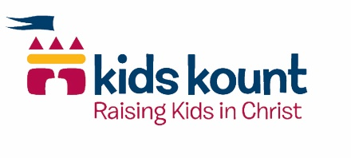
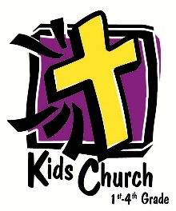
Kids Church
Gr. 1 - 4

Year 1
Summer – Discover the Design, Pass the Promise
Fall – Pass the Promise
Winter – Jesus is the King
Spring – The Early Church

Year 2
Summer – God is Our Rescuer
Fall – God is Our Rescuer (continued)
Winter – Jesus is our King, Meet the God/Man Jesus!, Meet Jesus the Sacrifice and…
Spring – Jesus is Lord of All, A Miraculous Church

Year 3
Summer – Lookin’ for a Leader
Fall – Lookin’ for a Leader (continued)
Winter – Real Life Stories of God Sightings, Meet the Amazing Jesus
Spring – Jesus Now, Mission Adventure

Year 4
Summer – Memorial Day, The Ten Commandments, God’s Power, Godly Actions Count
Fall – Good Kings – Bad Kings, Aliens in a Strange Land
Winter – The Best Gift of All – Jesus, Signs on Believers Hwy
Spring – Signs on Believers Hwy (continued), God in the Storms of Life

