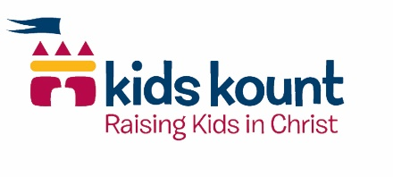
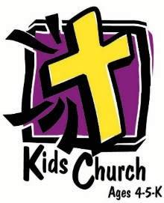
Kids Church 4-5-K

Year 1
Summer – God Made Everything, God Saves and Protects Us, God’s Rules are Cool!
Fall – God is Our King, God is Powerful, God Talks to Me
Winter – Jesus Our Savior Came to Earth, Jesus is Our Friend, Jesus is Our Helper, Jesus Gave Himself for Me
Spring – The Gifts from Jesus, We are in God’s Family

Year 2
Summer – I am God’s Child, God is Awesome, God Teaches Us His Ways
Fall – God Forgives Me, God’s Creation is Grrreat!, God Keeps His Promises, God is There in Tough Times
Winter – God Gives the Best Gifts, Jesus is God’s Son, Jesus Takes Care of Me, Jesus Gave His Life for Me
Spring – We are God’s Church, We are in God’s Family

